**Cosmo Fireplace**

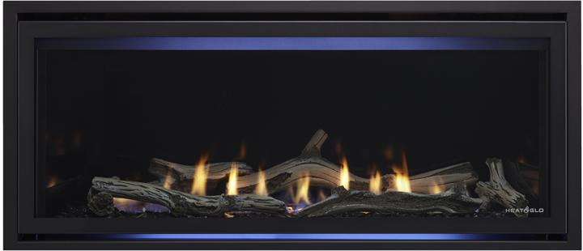

## Modern sophistication for any room

**Starting at  $2,998**

**Product only. Pricing exclusions apply. Contact a dealer for more information.**

Set the tone when gathering with friends and family with a modern fireplace. The Cosmo linear indoor gas fireplace fits the trends of our 16:9 ratio world, which makes it perfect to sit below a TV. Clean, chic, and affordably yours.

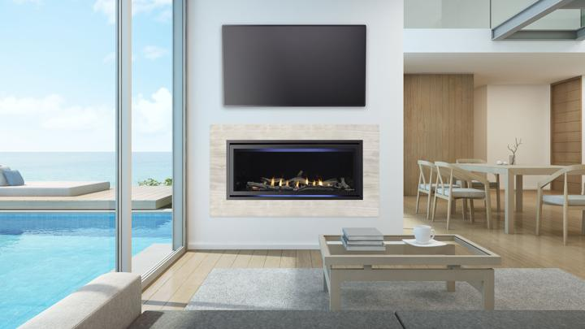

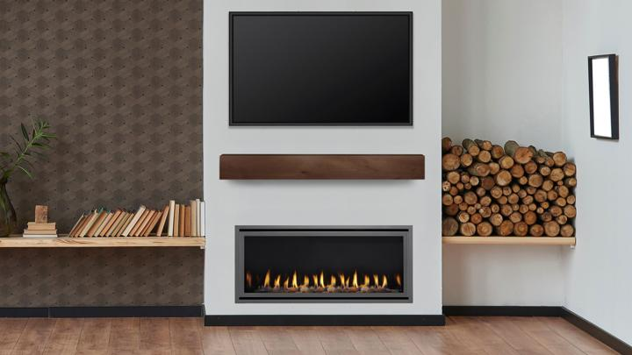

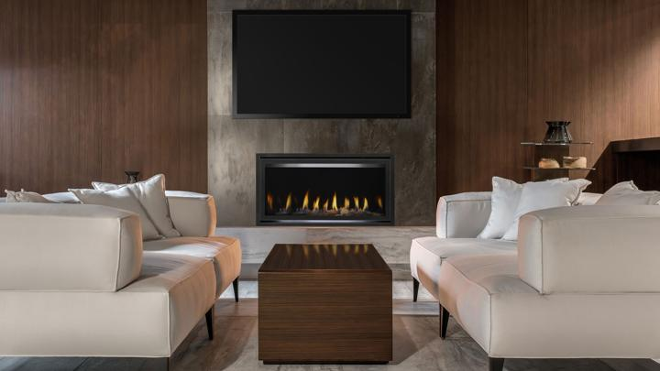

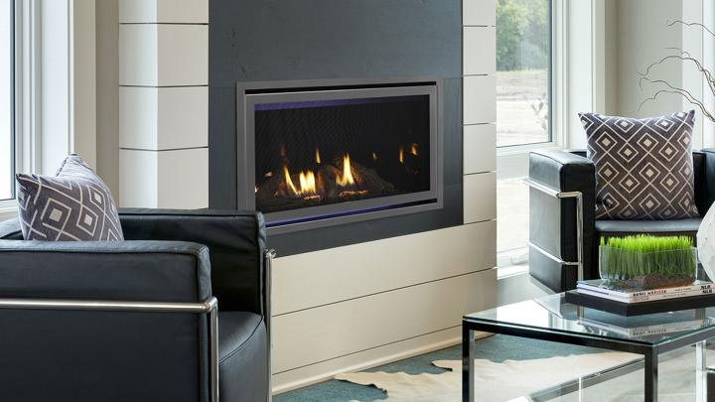

<https://youtu.be/NLDXr1oUDEo>

## Features

### BATTERY BACKUP

Ensures you always have a reliable source of warmth even with a winter power outage.

### DIRECT VENT TECHNOLOGY

Removes any fumes or combustion exhaust efficiently and effectively from your home.

### INTELLIFIRE TOUCH®

Offers you a touchscreen remote control or wireless wall switch to fit your life.

## Options

Accent lighting

Set the mood with dramatic accent lighting on select models. Light up your space with or without the fire.

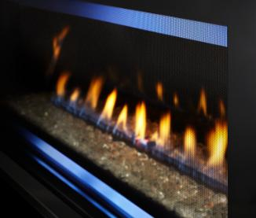

**LED Interior Lights**

Fan

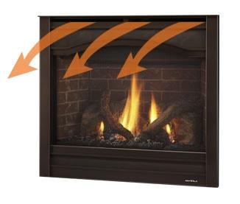

**Fan**

Fire bed material

The interior look helps make your fireplace your own. With natural substrates that complement the fire, you can express your style in unique and captivating ways.

 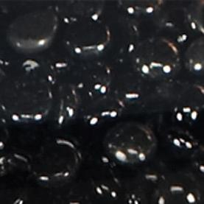

**Clear**

**Cobalt Blue**

**Black**

**Amber**

  

**Crystal**

**River Rock**

**White**

Fronts and Doors

Add a finishing touch to enhance your fireplace and distinguish your home. Browse fireplace fronts that frame your opening and glass or mesh doors in colors to complement your décor. Colors on screen can vary. Connect with your local dealer online or in person to see actual samples.

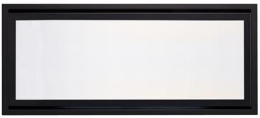

**Clean Face Trim**

  

New Bronze

Graphite

Black

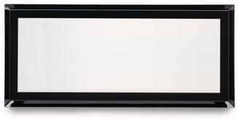

**Martini**

 

New Bronze

Graphite

Heat Management

Explore a range of solutions to send the heat where you want it or control the fireplace output for maximum comfort.

**Heat Out**

**Heat Zone**

**Passive Heat**

**Passive Heat Front Trim Kit**

Interior panel

Make your fireplace your own by personalizing the interior of your firebox from the many choices available. Options may vary by model. See your dealer for details.

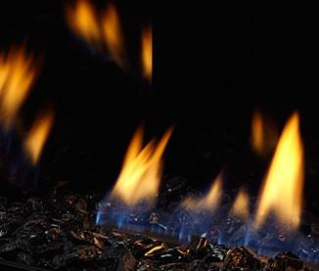

Fade-resistant Black Glass

Remotes/Wall Switches

Experience easy, convenient control to fit your lifestyle. See your dealer for details.

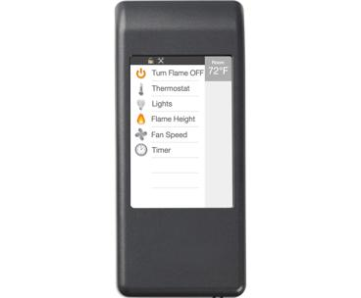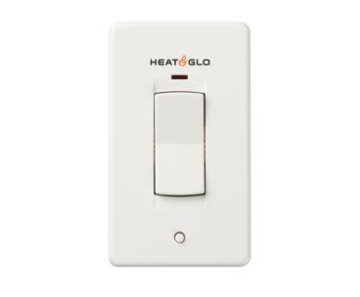 

**Wi-Fi Module for IntelliFire App**

**Wall Switch**

**Remote Touchscreen**

Shelves

Customize your fireplace with mantel shelving. Our exclusively designed shelving adds a distinctive touch to any fireplace in lengths and designs to accent any room.

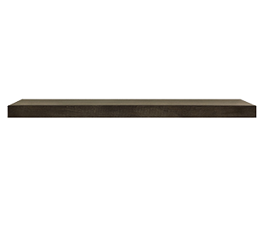 

Fillmore 48" Fillmore 59"

 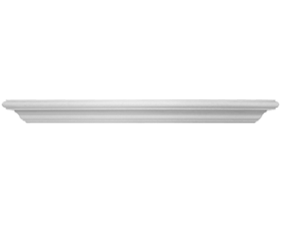

Fillmore 72" Gifford 48"

 

Gifford 59" Gifford 72"

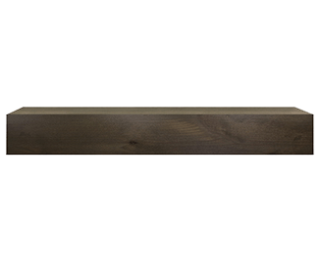 

Ozark 48" Ozark 59"



Ozark 72"

Surround

Hide any gap between your gas fireplace insert and the existing fireplace opening with a low-profile surround composed of steel or cast iron.

 

Small 30" surround 40" x 27" - Black Small 30" surround 40" x 27" - Graphite

 

Small 30" surround 40" x 27" - New Bronze Medium 30" surround 42" x 30" - Black

 

Medium 30" surround 42" x 30" – Graphite Medium 30" surround 42" x 30" - New Bronze

 

Medium 30" surround 42" x 30" x 2" deep – Black Large 30" surround 44" x 32" - Black

 

Large 30" surround 44" x 32" – Graphite

## Specs[*](https://www.heatnglo.com/fireplaces/gas/see-through/primo-gas-fireplace#notice)

|  |  |  |
| --- | --- | --- |
| **Model** | Cosmo Insert 30 | Cosmo Insert 35 |
| **Minimum Opening Front Width** | 31-5/8" | 36-5/8" |
| **Minimum Opening Back Width** | 20-1/8" | 25-1/8" |
| **Minimum Opening Depth** | 15" | 15" |
| **Minimum Opening Height** | 21" | 24-1/4" |
| **BTU/hr Input** | 28,000 | 30,000 |
| **Viewing Area** | 27-1/2" x 15-15/16" | 32-1/2" x 19-3/8" |

## Downloads[*](https://www.heatnglo.com/fireplaces/gas/see-through/primo-gas-fireplace#notice)

[**Cosmo IFT**](https://downloads.hearthnhome.com/installmanuals/2535_980_COSMO-I30-35-IFT_INSTALL.pdf) [**Cosmo IFT**](https://downloads.hearthnhome.com/installmanuals/2535_981_COSMO-I30-35-IFT_OWNER.pdf) [**COSMO 30 w/IFT (COSMO-I30-IFT)**](https://downloads.hearthnhome.com/serviceParts/COSMO-I30-IFT.pdf)

[**Gas Insert**](https://downloads.hearthnhome.com/brochures/HNG-1142U.pdf) [**Mantels and Surrounds**](https://downloads.hearthnhome.com/brochures/FSF-1016U_Mantels.pdf)